**Experiment No. 4: Ramjet**

Aim: To determine the performance of fuel rich propellant based ramjet and a hybrid ramjet.

**Introduction**

A solid fuel ramjet (SFRJ) powered with a fuel-rich propellant (FRP) has two combustion chambers. The FRP burns in the primary combustor and ejects fuel-rich gases through a choked nozzle as shown in Fig. 1. These Fuel-rich gases burns with air rammed in though the intake in the secondary combustor. The gaseous combustion products are then expanded and ejected out through the secondary nozzle to provide the thrust. The pressure in the primary chamber is independent of the pressure in the secondary chamber, the flight altitude and the Mach number. It depends only on the burn rate law of the propellant and the nozzle diameter.

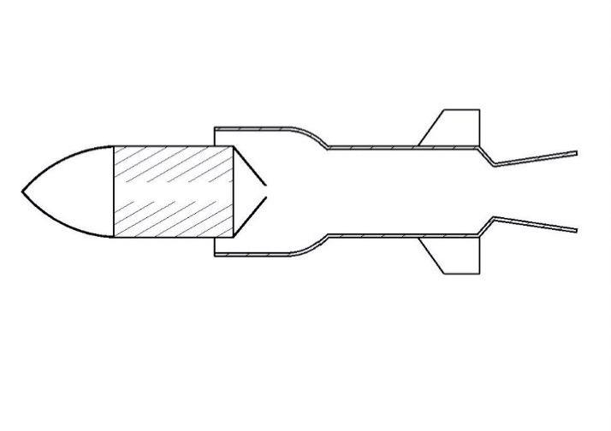

Fuel-rich propellant

Air

Primary Combustor

Secondary Combustor

**Fig. 1 Schematic of SFRJ with two combustion chambers.**

**Apparatus: Ramjet thrust stand**

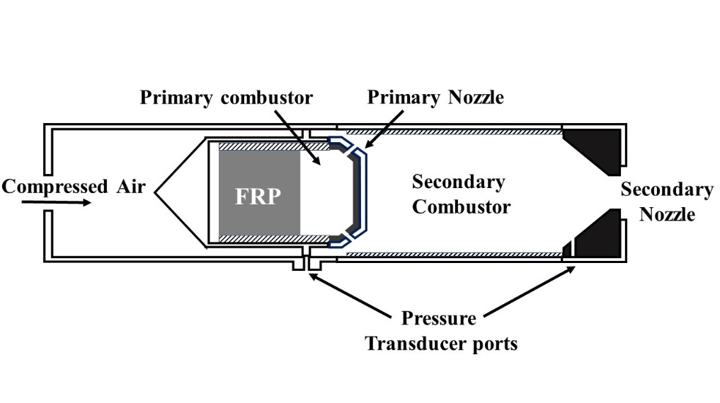

**Fig. 2 Ramjet setup**

**Experimental Setup and Procedure**

1. Measure the mass and density of the fuel block.
2. Complete the installation of ramjet after loading the fuel and connecting the pipelines for air supply.
3. Connect the pressure transducer to the ports provided and then to the computer through a data acquisition system (DAQ).
4. Connect the rotameter to measure the air mass flow rate.
5. Connect the sequential timer and ignition battery as shown in Fig. 3.
6. Initially only air is supplied and after a set delay the ignitor for the fuel rich propellant is switched on.
7. Measure the total bun time, mass flow rate of air, mass flow rate of fuel and the pressures in Primary chamber ($P_{C1}$)and secondary chamber ($P_{C2}$).

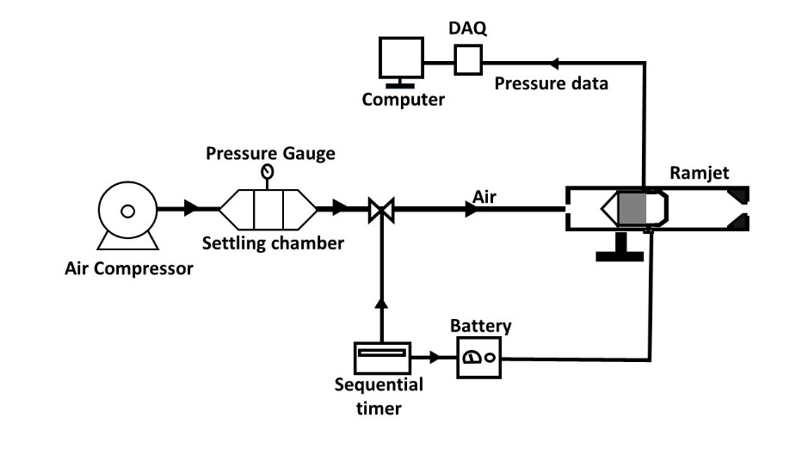

**Fig. 3 Schematic of the test set up.**

**Measured Data**

|  |  |
| --- | --- |
| Total burn time, 𝑡𝑏 | **11.6 s** |
| Fuel-rich propellant mass, 𝑀𝑓 | **86.14 g** |
| Mass flow rate of air, 𝑚𝑎̇ | **87.97 g/s** |
| Primary Chamber Pressure, 𝑃𝐶1 | **5.34 bar** |
| Secondary Chamber Pressure, 𝑃𝐶2 | **2.95 bar** |

**Tabular Column**

|  |  |  |  |  |  |
| --- | --- | --- | --- | --- | --- |
| **Test No** | **Total burn time $$t_{b}$$**  **(s)** | **Fuel-rich propellant mass $M_{f}$**    **(kg)** | **Mass flow rate of air $$\dot{m_{a}}$$**  **(kg/s)** | **Primary Chamber Pressure, $P_{C1}$**  **(bar)** | **Secondary Chamber Pressure, $P_{C2}$**  **(bar)** |
| 1 |  |  |  |  |  |

**Calculations:**

Mass flow rate of fuel, $\dot{m_{f}}=\frac{M_{f}}{t_{b}}$

Air-fuel ratio, $A/F=\frac{\dot{m_{a}}}{\dot{m_{f}}}$

Combustion efficiency, $η_{c^{*}}=\frac{c_{exp}^{*}}{c_{theo}^{*}}$

( $M_{f}$– Total mass of fuel; $t_{b}$– Total burn time)

**Result and Discussion**

**Conclusion**

**PTO for the other experiment**

In this experiment a solid fuel ramjet (SFRJ) with a wax-Aluminium based solid fuel is used. The compressed air/ram air—provided from an external compressor—will act as the oxidiser for the fuel block. In essence, the system is similar to a hybrid rocket motor with solid fuel and air as oxidiser. The regression rate of the fuel will depend up on the mass flux of the oxidiser. The empirical formula for fuel regression is given as following

$$\dot{r}=aG_{ox}^{n}$$

Where, $\dot{r}$ is the burn rate and $G_{ox}$ is the oxidiser mass flux.

The fuel-oxidiser combustion is initiated using a solid propellant ignitor. The gaseous combustion products are then expanded through a convergent nozzle to generate thrust.

**Apparatus:**

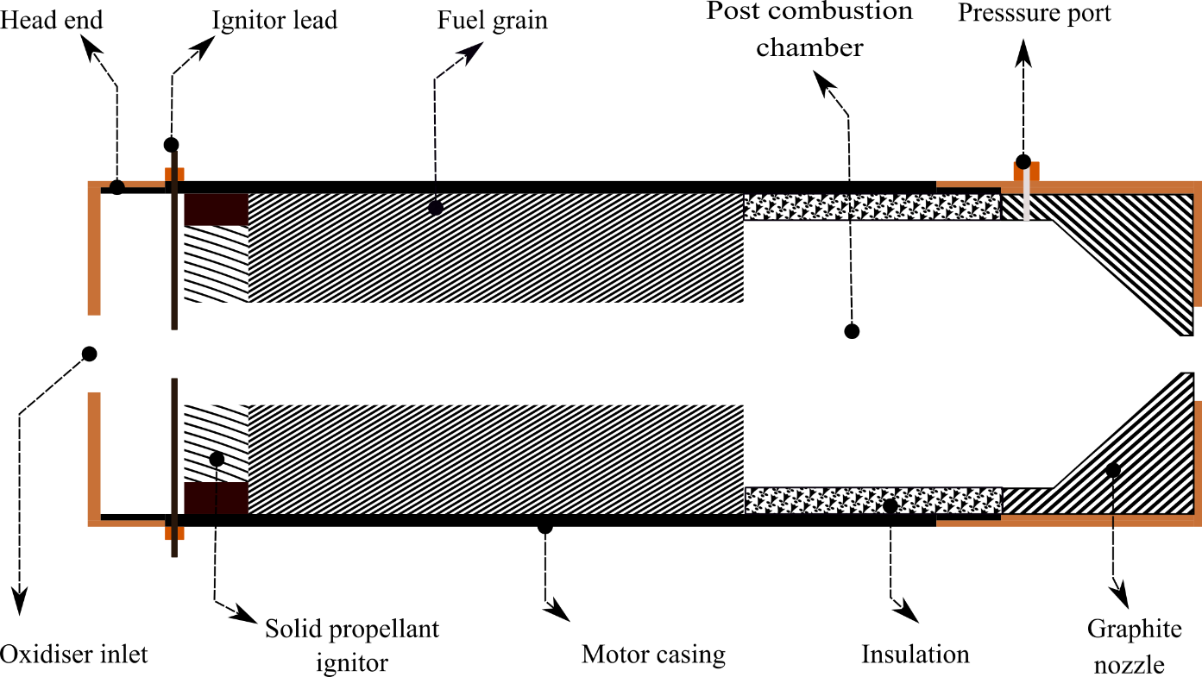Figure1 shows the schematic of the ramjet. The ramjet is mounted on a stationary thrust stand and the compressed air is provided from an external compressor. The flow rate of the compressed air is measured using a flow meter. A pressure port at the end of the post-combustion chamber is used to measure the chamber pressure. Thrust measurement is obtained using a load cell that is attached with the thrust stand. The test facility has the capability to adjust the oxidiser flow rate using a proportional valve assembly. A data acquisition system logs the data from loadcell, flowmeter and the pressure transducer. A sequential timer is used to activate the ignition battery and the microcontroller. The microcontroller which is pre-programed with the testing sequence will control the oxidiser flow rate.

Figure 1: Schematic of Ramjet

**Experimental Procedure**

1. Measure the mass, length and port diameter of the fuel.
2. Load the fuel and ignitor, and assemble the ramjet.
3. Mount the ramjet on the thrust stand and connect the air supply line.
4. Connect the pressure transducer to the port provided.
5. Connect all the sensors to the data acquisition device (DAQ).
6. 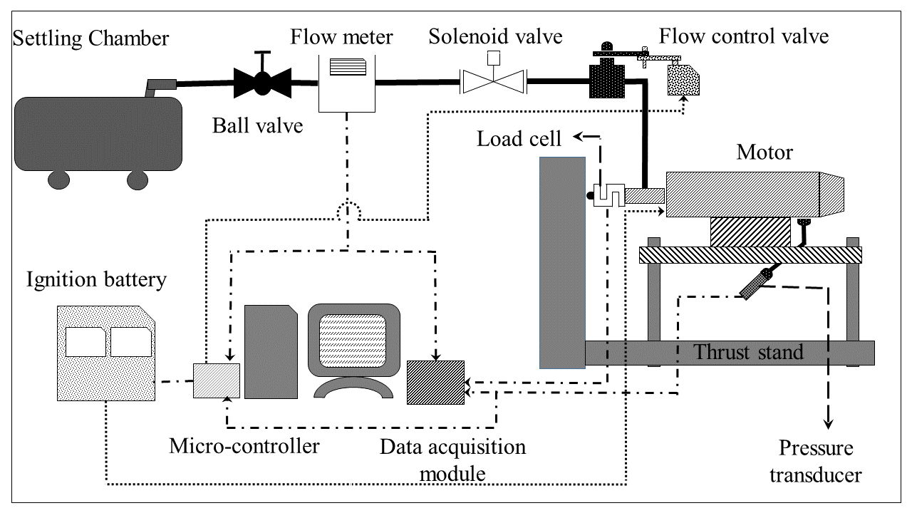Open the ball valve for the air supply form the settling chamber

**Fig. 3 Schematic of the test set up.**

1. Connect and configure the sequential timer and ignition battery.
2. Initiate the test with sequential timer.
3. Note down total bun time, chamber pressure, mass flow rate of air, weight loss of the fuel and the thrust.

**Observations**

Port diameter (mm)                           =  20.5 mm  
Fuel length (mm)                               =  100 mm  
Nozzle Throat Diameter(mm)            =  18 mm

Theoretical c*                                     =  1335.6 m/s

|  |  |  |  |  |  |  |
| --- | --- | --- | --- | --- | --- | --- |
| **Test No** | **Total burn time $$t_{b}$$**  **(s)** | **Initial mass of the Fuel. $(M_{f}^{initial})$**  **(kg)** | **Final mass of the Fuel ${ (M}_{f}^{final})$**  **(kg)** | **Mass flow rate of air $$\dot{m_{a}}$$**  **(kg/s)** | **Chamber Pressure, $P_{C}$, bar** | **Thrust**  **(N)** |
| 1 | 17 | 0.365 | 0.177 | 0.077 | 4.0 | 92.7 |
|  |  |  |  |  |  |  |

**Calculations:**

Mass flow rate of fuel, $\dot{m_{f}} =\frac{M_{f}^{initial}-M_{f}^{final}}{t_{b}}$

Air-fuel ratio, $A/F =\frac{\dot{m_{a}}}{\dot{m_{f}}}$

Combustion efficiency, $η_{c^{*}}=\frac{c_{exp}^{*}}{c_{theo}^{*}}$

**Results and Discussions**

**Conclusions**